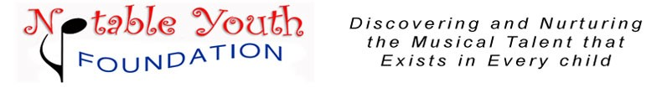

NOTABLE YOUTH POPS ORCHESTRA

MISSION: The Notable Youth Pops Orchestra is a youth orchestra primarily serving the community of South Valley. Its focus is unique in that it trains youth from ages 5 to 18 to perform simple music well. The general repertoire is taken from popular classical music, children’s classics, popular music, Movie and TV scores, and patriotic/holiday themes.

PERFORMANCES: Draper Days, Utah State Fair, Disneyland, Festivals of SLC, Thanksgiving Point Bug State, Amphitheatre, BYU, U of U, Art Festivals, Christmas Festival of Trees, & others.

DIRECTOR: Dan Whitley: piano, voice, guitar, horns, strings, drums
801-918-7740 Draper, Utah

Like our website -more details, schedules, teaching
methodology, credentials, YouTubes, photos, store, etc.
www.danwhitleymusic.com danwhitley@gmail.com
“Music Makes the Difference” 